

**The list of terminology**

Based on the several times’ discussion on the 1st, 2nd and 3rd international workshop of jointless bridges and the effect of committee of International Association of Jointless Bridges(IAJB), the terminologies related to jointless bridge were confirmed by the IAJB. The list of terminology is following and also will be released in the Website of IAJB.

**1. Jointless Bridges (JBs)**

“Jointless bridge is a bridge with continuous superstructure and without movable deck joint between the outer ends of approach slabs”.

Three main kinds of jointless bridges and their definitions are adopted by IAJB.

**1.1 Integral abutment bridge (IAB)**

Bridge with two integral abutments; for multi-span bridge, its superstructure is in continuity.

**1.2 Semi-Integral abutment bridge (SIAB)**

Bridge with two semi-integral abutments; for multi-span bridge, its superstructure is in continuity.

**1.3 Deck-extension bridge (DEB)**

Bridge with two deck-extension abutments; for multi-span bridge, its superstructure is in continuity.

By the way, other types of jointless bridges (such as deck-continuous bridge, abutmentless bridge, combination or variation of three main JBs) are not categorized as main JBs and not recommended in engineering application. If adopted, extra explanation and calculation are needed.

**2. Abutments**

**2.1 Integral abutments (IA)**

Integral abutments are “the abutments are integral with the superstructure and consider with full-height soil pressure.”

**2.2 Semi-integral abutments (SIA)**

Semi-Integral Abutments are “the abutments that are integral from the superstructure through a portion of the abutment stem and consider with partial-height soil pressure.”

**2.3 Deck extension abutments (DEA)**

Deck extension Abutments are “the abutments are not integral from the superstructure and without considering the soil pressure.”

**3. Slab**

For small bridge, one piece of slab is provided on each side. For medium or large bridge, two pieces of slabs are usually installed on each side. The one near to bridge end is defined as approach slab, and the other one far away bridge end is defined as transition slab.

**3.1 Approach slab**

Approach slab is a part of a bridge that rests on the abutment at one end and on the embankment or a sleeper slab on the other end.

It could be flat or inclined, as well as on the surface of backfill or being embedded in the backfill. Three main kinds of approach slab and their definitions are adopted by IAJB.

**3.1.1 Grade flat approach slab**

It has the same elevation with road surface and works as an approach area between bridge and road pavement.

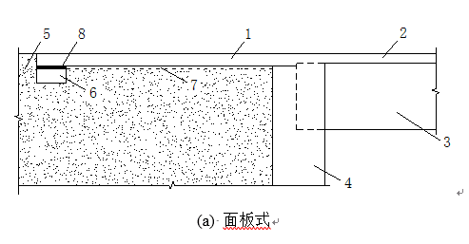

**3.1.2 Buried flat approach slab**

It is a flat approach slab embedded under a depth of bridge deck or road surface.

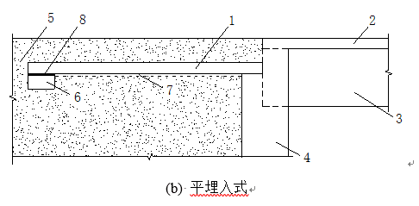

**3.1.3 Buried inclined approach slab**

It is an inclined approach slab embedded underneath the approach area.

1-Approach slab; 2-Deck; 3-Girder; 4-Abutment; 5-Backfill; 6-Sleeper; 7-Slip layer; 8-Teflon

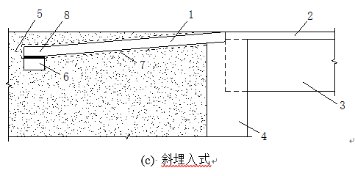

**3.2 Transition slab**

Transition slab is a kind of slab located between approach slab and road pavement to better relief transfer of longitudinal bridge deformation.

**3.3 Link slab**

It is a functionally designed slab monolithic with bridge deck to cover the gap between girders and keep the deck continuous.

**3.4 Sleeper beam**

Sleeper beam is a grade beam supporting far end of an approach slab to reduce or stop the settlement of approach pavement.

**4. End wall**

End wall is the upper portion of “abutment”, which works as both soil retainer and end diaphragm.

**5. Back wall**

Back wall is the part of abutment above the bearing seat to resist the soil pressure from backfill and also support the sliding deck in deck extension bridges.

**6. Joint**

**6.1 Movable deck joint**

Movable deck joint is a kind of joint which allows two sides of the joint to open or close due to thermal variation.

**6.2 Relief joint**

Relief joint is a kind of joint that allows two sides of the joint to open or slip due to contraction, but no expansion is allowed.

**6.3 Construction joint**

Construction joint is a kind of joint due to the requirement of construction. The interface has no gap and is kept in close touch by concrete bondage and reinforcement.