The 2nd International Symposium on Jointless & Sustainable Bridges（ISJSB2019）

July 15-19, 2019

Hosting Organization:
International Association of Jointless Bridges (IAJB)

Organizers:
Northeast Forestry University (NFU)
Fuzhou University (FZU)
International Association of Bridge Earthquake Engineering (IABEE).
Committee of Sustainable Civil Engineering, Urban Science Research Institute, China

Conference Location:
Northeast Forestry University, 26 Hexing Road, Xiangfang District, Harbin, Heilongjiang, China

About the Symposium

Introduction

Sustainability is a holistic concept that is becoming increasingly important in the construction sector. Jointless bridge meeting sustainable development trend has been widely used in developed and is being promoted to developing countries. Compared with the conventional bridge, it has lower maintenance costs due to elimination of joints, improved vehicular riding quality due to the smooth, uninterrupted deck, lower noise, as well as larger mitigation capability against disaster.
In order to promote the application and development of jointless bridges, the International Association of Jointless Bridges (IAJB) was established during the first international Workshop of jointless bridge held in Fuzhou (China) on March 8-14, 2014. Subsequently, four workshops were held in China and the United States in 2015, 2016, 2017 and 2018, respectively. The jointless bridge terminology, international guideline, technical development direction and association work were discussed in these workshops and important progress was made.
The International Association of Jointless Bridge held the first International Symposium on Jointless & Sustainable Bridges (ISJSB'2016) in Fuzhou (China) from May 12th to 14th, 2016. Experts and scholars from China, United States, Canada, Italy, Spain, Germany and Turkey participated in the conference, and conducted in-depth discussions and exchanges on topics such as design, construction, maintenance and retrofitting of bridges without expansion joints. The topic of sustainable bridge technology was also discussed. The IAJB Association decided to hold the ISJSB meeting every three years, and to organize the second Symposium (ISJSB'2019) in Harbin (China) from July 15-19, 2019.
Experts and researchers are welcome to attend the Symposium to exchange ideas and experiences on bridge design, construction and maintenance issues as well as ideas for future growth and sustainability.

Symposium Topics
Topics to be covered in the Symposium include but are not limited to:
- Codes and guidelines for Jointless Bridges
- Soil Structure Interaction (SSI)
- Seismic Response and Resilience of Jointless Bridges
- Design of Jointless Bridges
- Retrofitting of existing conventional bridges to a new integral configuration
- Development of Sustainable Bridges
- New and high performance materials for durable Bridges
- Life cycle cost of Bridges
- Health monitoring of bridges
- Durability performance of bridges

Registration

The conference registration fee includes: a) attendance; b) proceedings in CD; c) lunch and coffee breaks; e) conference banquet and welcome reception.
Accompanying person will not receive the proceedings.
Registration Fee | Early Bird fee  Until June 15, 2019 | Standard Fee  After June 15, 2019
Delegate | $600/￥4000 | $800/￥5500
Student | $300/￥2000 | $400/￥2750
Accompanying Person | $400/￥2750

Call for Abstracts

A request for abstracts for the ISJS2019 Symposium is now open.
The abstract and full paper templates can be downloaded at: http://jointlessbridges.fzu.edu.cn/.
The abstract format file name is: IAJB2019_Abstract_ Template; the full-text format file name is: IAJB2019_FULLpaper_Template.
Please submit your abstracts by April 15, 2019 to the following emails:
E-mail:huangfuyun@fzu.edu.cn or ldzhxldzhx@163.com.

Selected papers will be recommended for publication in a special issue of Journal of Bridge Engineering (2019, Jointless Bridge), ASCE.

The author is requested to submit a manuscript with the English abstract and the title of the paper, the author's name, the affiliation, the mailing address, the telephone/fax number and the e-mail address before the deadline of abstract submission, and submit the full paper within the specified time. Please indicate the following when submitting the manuscript:
2019 Seamless Bridge Workshop Secretariat
School of Civil Engineering, Northeast Forestry University
Harbin, Heilongjiang Province, China

Important Dates

Abstract Submission | April. 15, 2019
Abstract Acceptance | April. 30, 2019
Full Paper Submission | May 30, 2019
Pre-registration Due | June 15, 2019
Symposium | July 15-19, 2019

Committees

International Scientific Committee
Philip W. Yen, Chair | International Association of Bridge Earthquake Engineering (IABEE), USA
Alp Caner | Middle East Technical University, Turkey
Alessandro Palermo | University of Canterbury, New Zealand
Anastasisos Sextos | University of Bristol, UK
Baochun Chen | Fuzhou University, China
Bijan Khaleghi | Department of Transportation, Washington State, USA
Bruno Briseghella | Fuzhou University, China
Camillo Nuti | University of Roma Tre, Italy
Christian Binder | Schimetta Consult ZTGmbH, Austria
Chengyu Li | University of Colorado at Denver, USA
Damien Champenoy | Civil Engineering Structures, Cerema Est, France
Frank Y. Chen | Pennsylvania State University, USA
Fuyun Huang | Fuzhou University, China
George Mylonakis | University of Bristol, UK
Giuseppe Carlo Marano | Fuzhou University, China
Habib Tabatabai | University of Wisconsin-Milwaukee, USA
Hans Petursson | Swedish Transport Administration, Sweden
Ian Buckle | University of Nevada, USA
Jiangang Wei | Fujian College of Engineering, China
Jianzhuang Xiao | Tongji University, China
Khaled Sennah | Ryerson university, Canada
Peter Dusicka | Portland State University, USA
Philippe Jandin | Civil Engineering Structures, Cerema Est, France
Qingguo Ben | Sujiao Group Co., Ltd., China
Qiuhong Zhao | Tianjin University, China
Roman Geier | Schimetta Consult ZTGmbH, Austria
Stergios A.Mitoulis | University of Surrey, UK
Thomas Kuhnle | Schimetta Consult ZTGmbH, Austria
Tianlai Yu | Northeast Forestry University, China
Voo Yen Lei | Dura Technology, Malaysia
Xu Ming | Tsinghua University, China
Yiyan Chen | Shenzhen Municipal Design and Research Institute Co., Ltd., China
Yongjian Liu | Chang’an University, China
Yuanfeng Wang | Beijing Jiaotong University, China
Yizhou Zhuang | Fuzhou University, China

Organizing Committee

Tianlai Yu (Chair) | Northeast Forestry University, P.R.CHINA
Fuyun Huang (Co-Chair) | Fuzhou University, P.R.CHINA
Hongxiang Zhang (Secretary) | Northeast Forestry University, P.R.CHINA
Linda Kuo | International Association of Bridge Earthquake Engineering (IABEE), USA
Junqing Xue | Fuzhou University, China
Jiazhan Su | Fuzhou University, China
Yufan Huang | Fuzhou University, China
Guanglong Yu | Northeast Forestry University, China
Guowei Zhang | Northeast Forestry University, China
Yagebai Zhao | Northeast Forestry University, China
Hongguang Wang | Northeast Forestry University, China
Yan Yang | Fuzhou University, China

Conference Venue
The conference is located at Northeast Forestry University in Harbin, Heilongjiang Province, China.
The meeting address is: Northeast Forestry University, No. 26, Hexing Road, Xiangfang District, Harbin, Heilongjiang Province, China.
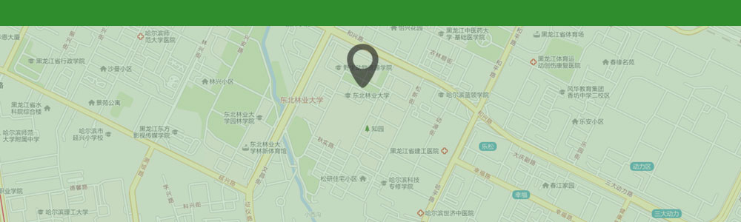
Northeast Forestry University

