

**The 3rd International Workshop on Jointless Bridges**

**Date:** May 30-June 3, 2017

**Hosting Institute:**

International Association of Jointless Bridges (IAJB)

**Organizers:**

Department of Transportation, Washington State (WSDOT),

University of Washington (UW)

Fu Zhou University (FZU)

International Association of Bridge Earthquake Engineering (IABEE).

**Conference Location:**

1410 NE Campus Parkway, Box 355852, Seattle, Washington State, USA

**Notification**

**1. INTRODUCTION**

There are very limited applications of jointless bridges (JBs) in China and other developing countries. Even there is no “National” design code or guide for JBs in the US and European countries, many JBs were constructed in recent years. This opens numerous research opportunities, and requires new ideas and experiences to be shared in improving safety and performance of JBs.

On March 11-13, 2014, the 1st international workshop on jointless bridges was successfully held in Fuzhou, Fujian, China. Based on many discussions of unsolved problems on jointless bridges in the workshop, all participants felt that it is very necessary to form an international association on jointless bridges to focus on the research and knowledge-exchange. As a result on June 2-4, 2015, a mini workshop on integral abutment and jointless bridges was again successfully held in Fuzhou University. The full name of the new association was named as International Association of Jointless Bridges (IAJB) and the administrative work are to be managed by Fuzhou University.

With a large demand in promoting the development of application and research on jointless bridges, the 3rd international workshop on jointless bridges will be held on May 30-June 3, 2017 in Seattle, Washington State, USA, and is now calling for papers.

**2. MEETING AGENDA**

May 30 (Tuesday) Arrival of Seattle and Registration;

May 31(Wednesday) Workshop meeting (Presentation and Tech Exchanges);

June 1(Thursday) IAJB Committee meeting - Discuss the progress and action items from last year (Morning);

Univ. of Washington Civil Eng. Lab. Study Tour (Noon) and Site visit of Washington State DOT Jointless Bridge (Afternoon);

June 2 (Friday) Option of Seattle City Technical Study Tour or Site visit of Washington State DOT ABC Bridges or Departure

June 3 (Saturday) Departure from Seattle (Those who are interested in participating in International Bridge Conference will fly to Washington, DC from June 4-8, and others will fly back to China).

**3. IMPORTANT DATES**

|  |  |
| --- | --- |
| Acknowledgement of Notification | Feb. 21, 2017 |
| Acknowledgement of Invitation Letter | Feb. 28, 2017 |
| Pre-registration Due | April 15, 2017 |
| Acknowledgement of Presentation | April. 30, 2017 |
| Workshop | May 30-June 3, 2017 |

**4. REGISTRATION FEE**

Delegate: US dollar 750/Chinese RMB 5000

Student: US dollar 375/Chinese RMB 2500

Companion: US dollar 375/Chinese RMB 2500 (including all meals)

The conference registration fee covers attendance, proceedings in CD, coffee breaks and refreshments, conference banquet and welcome reception. Accompanying person will not receive the proceedings.

Registration: On-site

**5. INTERNATIONAL SCIENTIFIC COMMITTEE**

|  |  |  |  |  |  |  |  |  |  |  |  |  |  |  |  |  |  |  |  |  |  |  |  |  |  |  |  |  |  |  |  |  |  |  |  |  |  |  |  |  |  |  |  |
| --- | --- | --- | --- | --- | --- | --- | --- | --- | --- | --- | --- | --- | --- | --- | --- | --- | --- | --- | --- | --- | --- | --- | --- | --- | --- | --- | --- | --- | --- | --- | --- | --- | --- | --- | --- | --- | --- | --- | --- | --- | --- | --- | --- |
| |  |  | | --- | --- | | **Name** | **Affiliation** | | Prof. Philip Yen (Chair) | International Bridge Seismic Committee (IBSC) | | Prof.Bijan Khaleghi (Co-Chair) | Department of Transportation, Washington State | | Prof. Baochun Chen (Co-Chair) | Fuzhou University, P.R.CHINA | | Prof. Yizhou Zhuang (Secretariat General) | Fuzhou University, P.R.CHINA | | Prof. Fuyun Huang (Vice Secretariat) | Fuzhou University, P.R.CHINA | | Ms. Linda Kuo | International Bridge Seismic Committee (IBSC) | | Prof. Bruno Briseghella | Fuzhou University, P.R.CHINA | | Dr. Alessandro Palermo | University of Canterbury, New Zealand | | Eng. Christian Binder | PCD ZTGmbH, Austria | | Prof. Habit Tabatabai | University of Wisconsin-Milwaukee, USA | | Eng. Hans Petursson | Swedish Transport Administration, Sweden | | Prof. Ian Buckle | University of Nevada, USA | | Prof. Khaled Sennah | Ryerson university, Canada | |  |  | | Dr. Peter Dusicka | Portland State University, USA | | Dr. Roman Geier | PCD ZTGmbH, Austria | | Eng. Thomas Kuhnle | PCD ZTGmbH, Austria | | Prof. Tobia Zordan | International Association for Bridge and Structural Engineering (IABSE) | | Prof. Y Frank Chen | The Pennsylvania State University, USA | |  |  | |  |

**6. ORGANIZING COMMITTEE**

|  |  |
| --- | --- |
| Prof. W. Phillip Yen (Chair) | International Bridge Seismic Committee (IBSC) |
| Prof. Bijan Khaleghi (Co-Chair) | Department of Transportation, Washington State |
| Prof. Baochun Chen (Co-Chair)  Prof. Jiangang Wei (Co-Chair)  Prof. Bruno Briseghella (Co-Chair) | Fuzhou University, P.R.CHINA  Fuzhou University, P.R.CHINA  Fuzhou University, P.R.CHINA |
| Dr. Fuyun Huang(Secretariat General)  Ms. Linda Kuo (Secretariat General) | Fuzhou University, P.R.CHINA  International Bridge Seismic Committee (IBSC) |
| Prof. Yizhou Zhuang (Vice Secretariat ) | Fuzhou University, P.R.CHINA |
| Ms. Yucai Zhong (Vice Secretariat ) | Fuzhou University, P.R.CHINA |
| Dr. Junqing Xue (Vice Secretariat ) | Fuzhou University, P.R.CHINA |
| Dr. Yufan Huang (Vice Secretariat ) | Fuzhou University, P.R.CHINA |

**7. MEETING VENUE**

The conference venue locates in University of Washington, HUB meeting center *depts.*,1410 NE Campus Parkway, Box 355852, Seattle WA, USA.

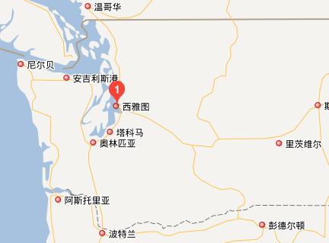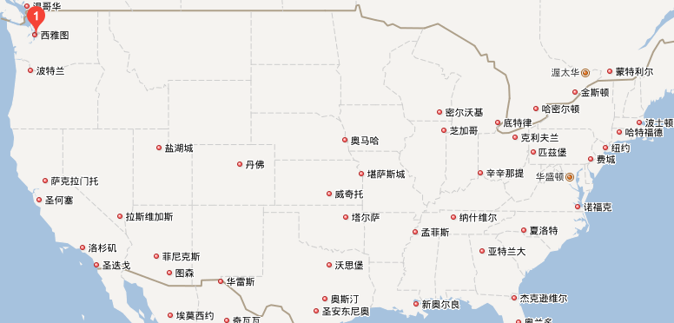

**USA**

**Seattle, WA**

**University of Washington**

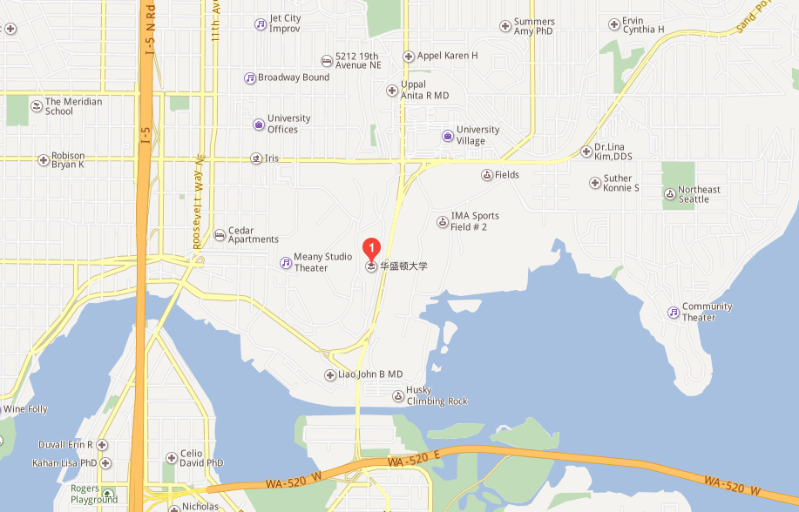

**8. LIVING HOTEL**

The hotel address: Seattle Airport Marriott, 3201 South 176th Street Seattle, Washington, 98188 USA

**Seattle Airport Marriott**

